Practice Quiz: Protein Synthesis - KEY

Biology AP

1a) The "lock and key" model describes a situation where the substrate that fits exactly into an active site of an enzyme. There is no change in shape of either substrate or enzyme. The "induced-fit" model describes a situation where the substrate and active site "mold" to fit to each other. Biologists have determined that the "induced-fit" model is what really happens. See Figure 8.16 on page 153 of your textbook.
1b) Tertiary
1c) Substrates may bond to the active site by ionic bonds, hydrogen bonds, or hydrophobic interactions.

2a) Competitive
2b) This is an example of competitive inhibition because the structure of oxaloacetate is similar to succinate so they probably compete for the active site.
2c) Yes
2d) By adding excessive succinate, you could reverse the inhibition because you would be outcompeting the inhibitor for the active site.

3a) Porphobilinogen
3b) Coproporphyrinogen III might build up to toxic levels
3c) 2

4a) Trypsin
4b) Cleaves a peptide bond to make two chains of a protein
4c) Disulfide bonds
4d) 245
4e) 241
4f) Phosphates groups can activate/inactivate enzymes. Inhibitors can bind to the active site (or another site on the enzyme). Coenzymes such as vitamins or cofactors such as Ca2+ (and other ions) can bind to enzymes to activate or inactive them.

5a) Inner portion of the protein
5b) These amino acids are hydrophobic which will be repelled from the watery environment of the cytoplasm. This region will most likely be found in the inner folds of the protein.
After careful experiments, you determine that the R groups of amino acids at positions 5, 7, 9, and 13 are very important in forming the active site of the MVBio-7 enzyme. They are vital in binding to the substrate (citric acid). Interestingly, glucose seems to inhibit the MVBio-7 enzyme. Glucose also seems to bind to the R groups of amino acids at position 5, 7, 9, and 13.
5c) Hydrogen bonding, ionic bonding, van der waals forces, hydrophobic interactions.
5d) Competitive
5e) The glucose binds to the same region as the substrate.

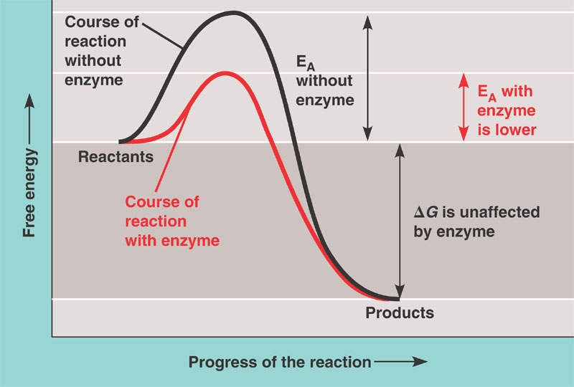
6a) protein
6b and c) It should look something like this:

6d) Exergonic
6e) hydrogen bond, ionic bond, disulfide bonds ( all tertiary structure bonds)
6f) Changing it to a positively charged amino acid will allow for additional ionic bonds between R groups. This could change the shape of the active site to allow it to bind to the substrate better than it did before.
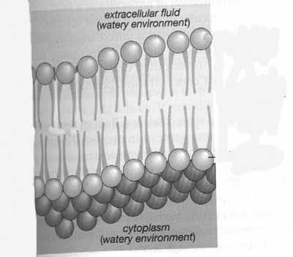
7a) phosphate area is circled

7b) unsaturated fatty acids
7c) If there were too many saturated fatty acids the membrane would be too solid at a cold temperature, thus killing the bacteria (like freezing it). At lower temperatures it is important for the membrane to remain fluid. This means you would want there to be more unsaturated fatty acids since they are able to remain more liquid/fluid at lower temperatures.

7d) nonpolar
7e) In order to get through the nonpolar center the molecule would also have to be nonpolar (and small). Note: water can pass through the membrane but it’s polar—it’s an exception.

8. One characteristic shared by all cells is the presence of the plasma membrane. The plasma membrane is often described using the Fluid Mosaic Model.
a) Which of the following would you expect to cause the membrane to be more solid (less fluid). Check all that apply:
______ Presence of cholesterol (at low temps) ______ High Temperatures
___X__ Presence of saturated fatty acids __X___ Low Temperatures
______ Presence of unsaturated fatty acids

8b) The membrane is a Mosaic because there are many different things in it such as phospholipids, proteins and carbohydrates.

9) c
10) b
11) b
12) c

13.
3'- cctcaaatcactctCCAGTTAGAacgacccttagtcacagtaagaatagggggacagatCCtagaATATTAagccctat -
5'- GGAgtttagtgagaGGTCAATCTtgctgggaatcagtgtcattcttatccccctgtctaGGatctTATAATtcgggata -

- tagacacaggagCGTTGgaCacagtaCCgaaTaCGtaagtttaccaggaagatggaagccaatcatgatagggggaatt –5
- atctgtgtcctcGCAACctGtgtcatGGcttAtGCatTcaaatggtccttctaccttcggttagtactatcccccttaa –3

a) Bold italicized above (5'- GGNCAATCT -3' and 5'- TATAAT -3')
b) see above (arrow)
c) The +1 position is either the C or A (big, italicized letters)
d) CAACC or AACCU
e) Met- Ala- Tyr- Ala
f) If this sequence were deleted, then the promoter regions would no longer be appropriately spaced apart, so the RNA Polymerase wouldn't bind here and this gene would not be transcribed.
g) a stop codon would be introduced—translation would stop too early. Incomplete protein made
h) RNA Polymerase reaches a termination signal.

14. There is NOT a guarantee of loss of protein function. The mutation may not cause a change in the amino acid that is coded for (because many codons can code for the same amino acid). If there is a different amino acid that is coded for, it may not change the overall protein structure that much, though, which would keep its function.

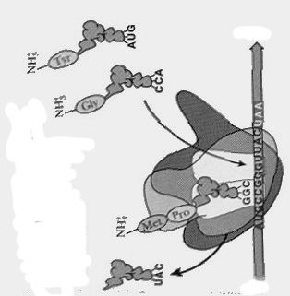
15.
A site
3’
5’
a) in diagram
b) in diagram.
c) in diagram
d) in diagram.
e) peptide bond
f) it will go get another amino acid attached to it.

16. b

17. b

18. a

19. a (you don’t need to know all of this for your quiz—just the material up to page 41 in the notes)
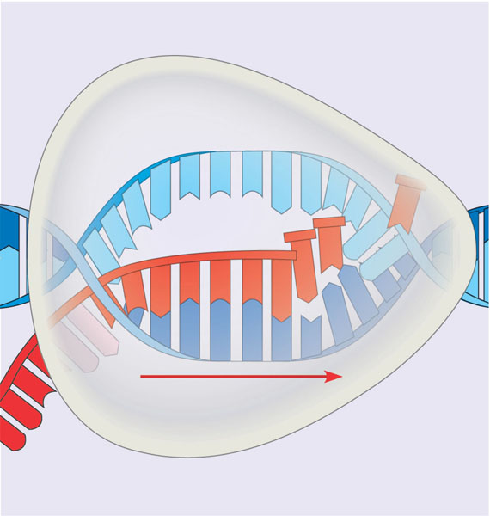
Strand A
Strand B
Direction of transcription
Strand C
20. AGCUCCA

21.
anticodon
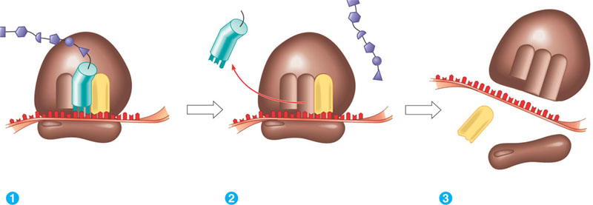
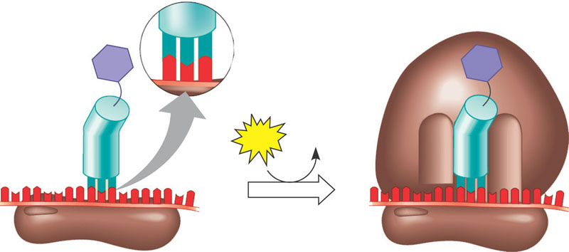
Amino acid

ribosome

mRNA

tRNA
polypeptide

Release factor

22.
RNA Splicing results in the removal of introns from pre-mRNA. The exons are kept and joined together, to create the final mRNA. A poly A tail and 5’ G cap are added to the two ends of the mRNA. This collective process of splicing and adding is called RNA Processing.
23.
a) Signal Sequence
b) Cytoplasm

24.
5-CTTGACACCGGATGCTTCCGGCTTCCCTATAATCGTATAGTGATTATGCCGTACCGTACG-3
3-GAACTGTGGCCTACGAAGGCCGAAGGGATATTAGCATATCACTAATACGGCATGGCATGC-5

a) The RNA polymerase will be chemically attracted to the -10 and -35 regions. It will bind to these regions if they are spaced out appropriately.
b) Bold italicized above (5-TTGACA-3 and 5-TATAAT-3)
c) The +1 position is either the G or T (big, italicized letters)
d) RNA Polymerase will transcribe from left to right
d) GUGAU or UGAUU
e) Methionine - Proline – Tyrosine

25. mRNA- translated into protein, tRNA- brings amino acids to the mRNA, rRNA- makes up part of the ribosome.
26.
5'-------------------------------------template----------------------------------------------------------------------------------3'
3' termination sequence-----------stop-----------coding---------start--------+1------------ -10 ---------- -35----------5'

27. a) Translation
b) It would prevent tRNA anticodons from binding to mRNA codons.
c) In addition, the microRNAs can also cause the RNA-RNA complex to be degraded by enzymes.

